|  |  |  |  |  |  |
| --- | --- | --- | --- | --- | --- |
| Date | 9-Dec-22 | | | Tester Name | Janette Paus |
| Environment | Penfax - Test 2 | | | Login used |  |
| Operating System | Windows | Version: 21H2 | Update Number: | | |
| Software Used | Select Software | Version: 107.0.1418.56 | Update Number: | | |
| Select Software | Version: | Update Number: | | |
| Application Release version | R22.4.1 | | | | |
| Test Case Title | E20.06 | | | | |
| Test Type | Regression | | | | |
| Test Scenario | Reverse an Interfund Transfer after Valuation | | | | |
| Expected Results | To reverse an interfund and for the funds to go back into their original fund. For the member’s amount of units to not change and the breakage entry to be reasonable | | | | |
| Pass/Fail | Select | | | JIRA# | <enter the new JIRA ticket number if the test case failed> |

To find an interfund transfer (done in office), search H:\Pension Programs\PEPP\Covid 19 Work Done\Current Month\Interfunds

SID:256267

Highlight the record and click Reverse

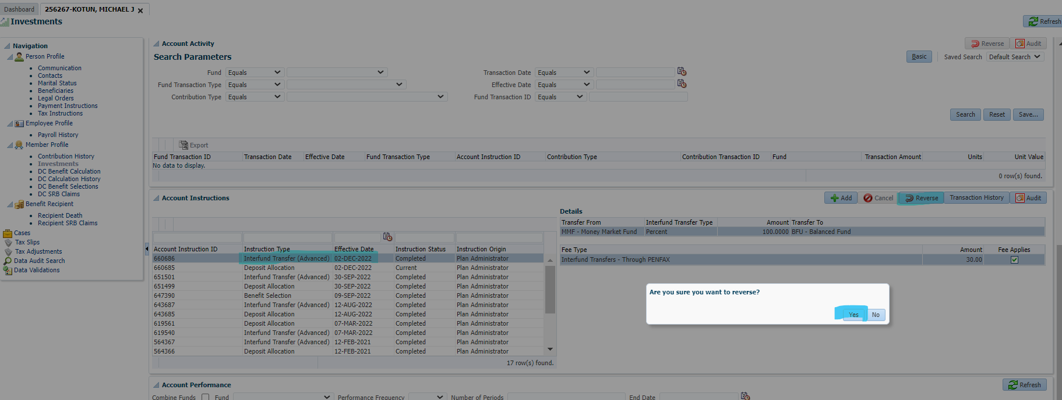

Status showing as “Pending Reversal”

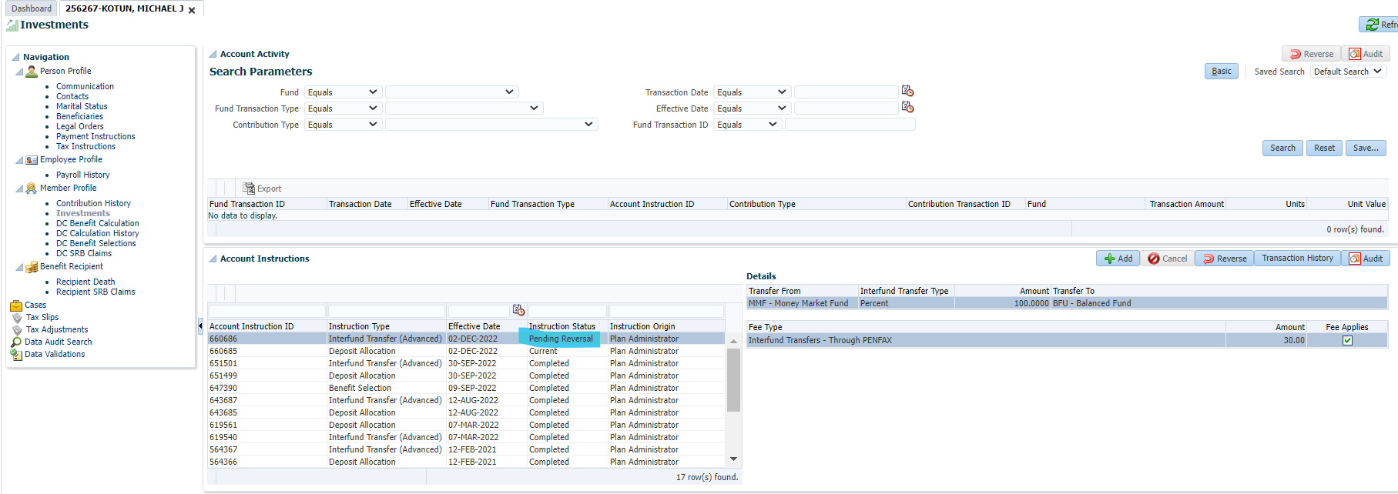

Funds are currently in Balance Fund

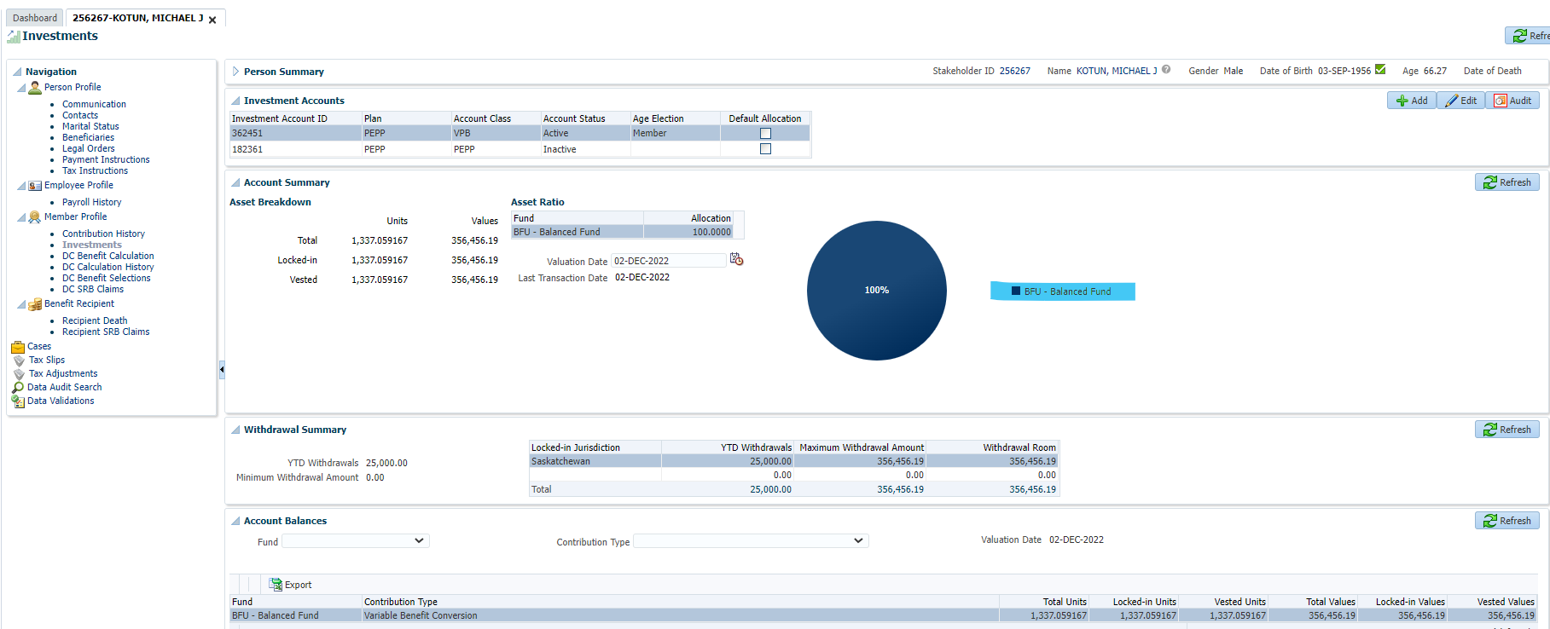

Next Day

Expect funds to show in Money Market Fund and for Breakage Occurrence to be present

Funds are correctly in the Money Market Fund

Breakage Occurrence is showing correct type and amount is reasonable